MODEL BUILDING

PREDICTIONS

|  |  |
| --- | --- |
| Team ID | PNT2022TMID03339 |
| Project Name | Early detection of forest fire using deeplearning |

# PREDICTIONS:

The last and final step is to make use of our saved model to do predictions. For that we have a class in keras called load_model. Load_model is used to load our saved model h5 file (alert.h5).

IMPORT LIBRARIES:

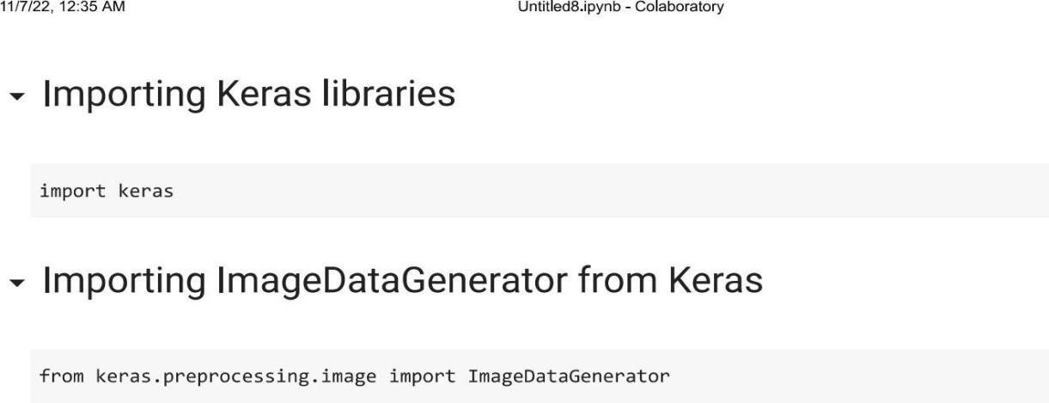

IMPORT ImageDataGenerator FROM KERAS:

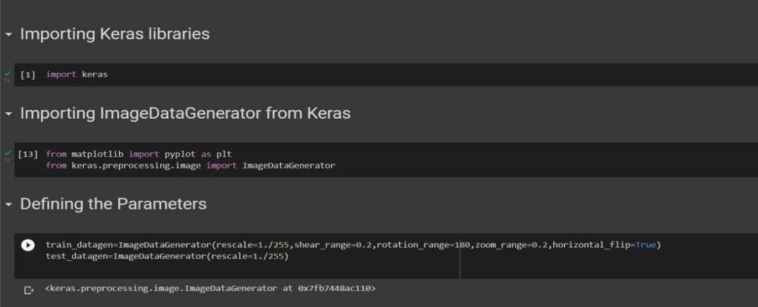

# APPLYING ImageDataGenerator to train dataset:

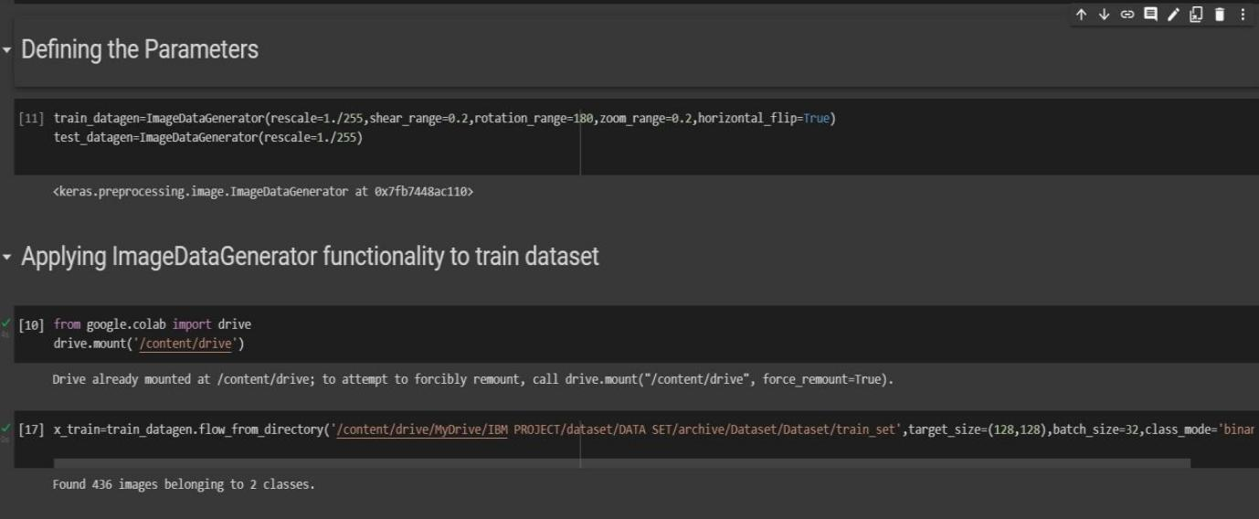ply**flow_from_directory ( )**methodfor Train folder.

# APPLYING ImageDataGenerator to test dataset:

Applying the **flow_from_directory ( )** methodfortest folder.

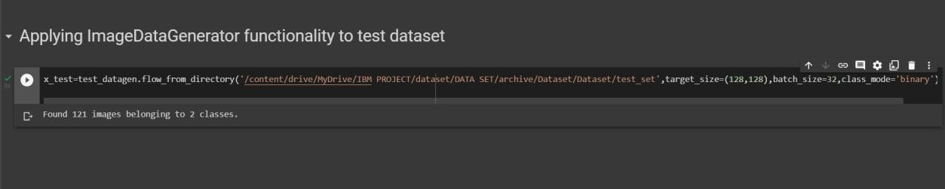

# IMPORTING MODEL BUILDING LIBRARIES:

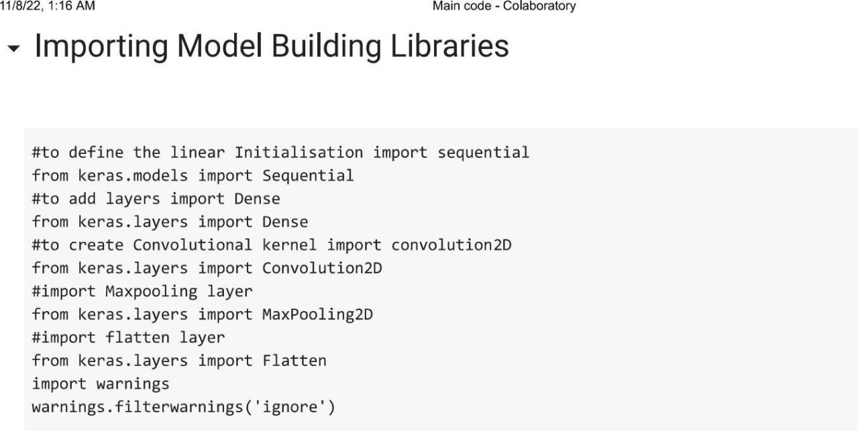

INITIALIZING THE MODEL:

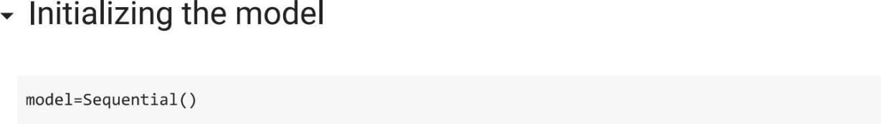

ADDING CNN LAYERS:

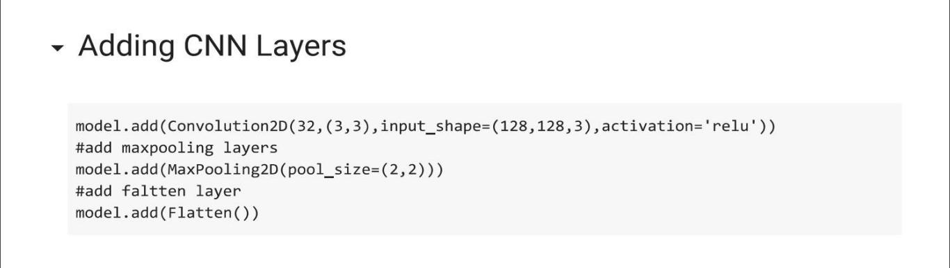

ADDING DENSE LAYERS:

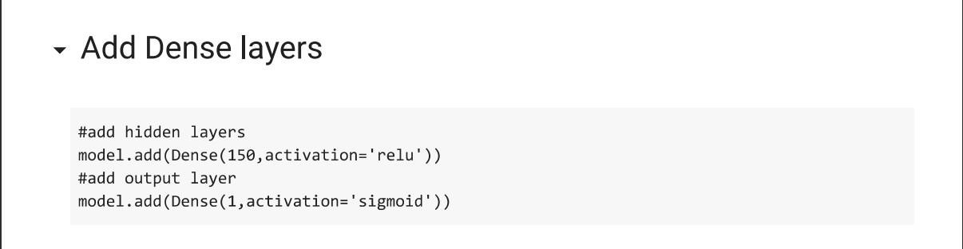

CONFIGURING THE LEARNING PROCESS:

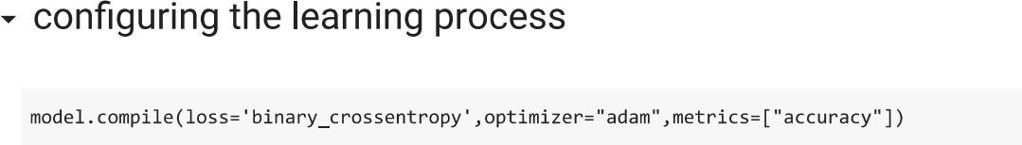

TRAINING THE MODEL:

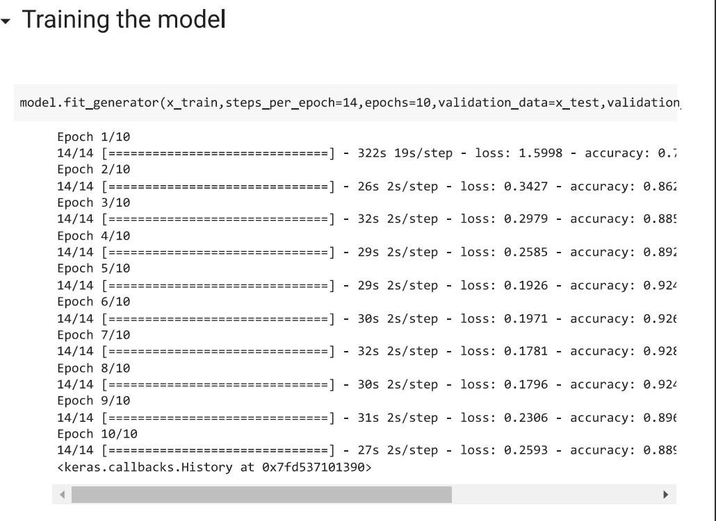

SAVE THE MODEL:

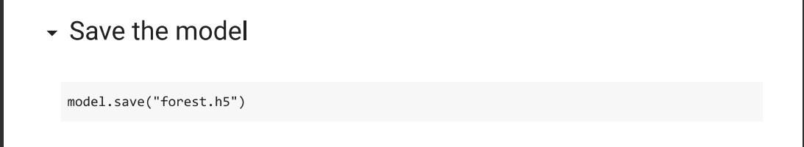

PREDICTIONS:

